ANNOUNCEMENTS:
Outreach: ‘Buckets of Hope’ is St. John’s monthly outreach for
SafeHaven Domestic Abuse Center. Our donations supply each family with the necessary supplies when they leave the shelter. Check the list in the Parish Hall to see what is needed. Please continue to bring non-perishable items for SAFPARC (Shawano Area Food Pantry). Items can be placed in the back of the church.

PICK UP IN THE RACK IN THE HALL:
- flyers that tell you about St. John's
- copies of sermons
- copy of the Church and Diocese electronic newsletter
- tracts that help with life's issues

St. John's Upcoming Special Events:
July 22-25: Vacation Bible School from 9-12 daily. See Meghan Keberlein for details and to volunteer to help out. Volunteers needed for snacks, crafts, music, games, teaching.
Sundays in July and August: Coffee hour mini-classes on the Lives of the Saints
September 8: 9:30 AM Outdoor mass, parish picnic and pony rides for children
September 8: 1:30 PM: Blessing of the Animals

The Fifth Sunday After Pentecost
June 30, 2013

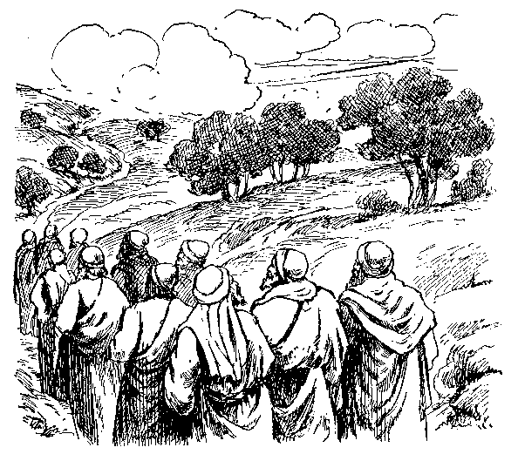
“And He sent Messengers Ahead of Him”

St. John’s Episcopal Church
141 South Smalley St., Shawano, WI
http://www.shawanoepiscopal.org
The Rt. Rev. Russell Jacobus, Bishop
The Rev. Mary S. Trainor, Vicar
Church Phone 715-526-3686
Vicar’s Phone 715-252-4816
pastormaryt@gmail.com

St. John’s Episcopal Church, Morning Prayer, Rite II

(please stand) Processional Hymn ………………………….#525
“The Church’s One Foundation”
Deacon: I was glad when they said to me “Let us go into the house
Of the Lord.
(please kneel if you are able)
Deacon: Let us humbly confess our sins unto Almighty God.
Confession of Sin (all together)………………….…BCP page 79
Deacon: Lord open our lips.
All: And our mouth shall proclaim your praise. Glory to the
Father, and to the Son, and to the Holy Spirit, as it was in the beginning, is now, and will be forever. Amen
Deacon: The Mercy of the Lord is everlasting: Come let us adore
Him.
Jubilate, page 82
(please sit)All: Psalm 77:1-2, 11-20.............……….bulletin insert
Gloria Patri, p. 84
Lay reader: Old Testament Lesson…………………. .bulletin insert
(please stand) All: Canticle 9: The First Song of Isaiah……
page 86 (please stand)
Lay reader: Epistle Reading……..………..bulletin insert
(please stand)ALL: Canticle 10:The Second Song of Isaiah...
page 86
Deacon: Gospel reading: Luke…………….….............bulletin insert
Sermon………………………………….…Deacon Bruce McCallum
The Apostles Creed, Page 96
Offering Hymn: “Sweet Hour of Prayer”…..Supplementary
Hymnal # 8
The Prayers
The Lords Prayer, page 97
Suffrage B, page 98
Collect of the Day (Insert)

Prayers of the People: Form VI …………………….p. 392
Those in need of our prayers: For healing: Marlene, Elora, Mike, George, Bernie, Dan, Adeline, Bruce, Pam, Julie, Frances, Laura, Dave, Gary, Clark, Gerald, Nora, Emma, Brian, Kathleen, Ann, Wendy, ; for Aaron, Ken and all those deployed, Diocesan Cycle of Prayer:St. Agnes, Algoma.

Prayer for election of a new Bishop, page 818
Prayer of St. Francis, page 833
Prayer of St. Chrysostom, page 59
Closing Hymn “Open My Eyes”……...Supplementary Hymnal #1
Announcements, Dismissal

TODAY at St. John's
Everyone is invited into the Hall for coffee during Fellowship time. This Fathers Day, Deacon Bruce will have a short lesson. Thank you to Deacon Bruce McCallum for serving as Officiant and Preacher today.
Announcements
Please sign up on the clipboard in the Hall for the various roles and tasks of the church. There are many ways to serve.

You can make a difference in helping out those less fortunate in Shawano. How? You can bring non-perishable (canned or dried goods) foods to church and place them in the basket near the Church entrance; food is delivered weekly to the Shawano Food Pantry (check dates on food please). You can also bring cleaning supplies and toiletry items for those staying at the Shawano Domestic Abuse Shelter; please place these items in marked bins.

The July-August Newsletter will go to press soon. Please get any articles to Pastor Mary within the next couple of days. Thank you!

